**SCD Lab 02**

**Name:** Hafsa Salman

**Roll no.** 22K-5161

**Task no. 01**

Code:

//Hafsa Salman  
//22K-5161  
//Task no. 01  
  
import java.util.InputMismatchException;  
import java.util.Scanner;  
  
public class Task_01  
{  
 public static void main(String[] args)  
 {  
 System.*out*.println("Name: Hafsa Salman");  
 System.*out*.println("Roll no. 22K-5161");  
 System.*out*.println("SCD Lab 02: Task no. 01");  
 System.*out*.println();  
  
 Scanner s = new Scanner(System.*in*);  
  
 int num;  
  
 try  
 {  
 System.*out*.print("Enter Integer: ");  
 num = s.nextInt();  
 }  
  
 catch (InputMismatchException e)  
 {  
 System.*out*.println();  
 System.*out*.println(e);  
 System.*out*.println("The input is invalid!");  
 }  
 }  
}

Output:

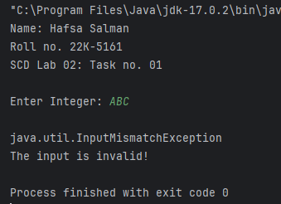

**Task no. 02**

Code:

//Hafsa Salman  
//22K-5161  
//Task no. 02  
  
import java.util.Scanner;  
  
public class Task_02  
{  
 public static void main(String[] args)  
 {  
 System.*out*.println("Name: Hafsa Salman");  
 System.*out*.println("Roll no. 22K-5161");  
 System.*out*.println("SCD Lab 02: Task no. 02");  
 System.*out*.println();  
  
 Scanner s = new Scanner(System.*in*);  
  
 String num_01;  
  
 System.*out*.print("Enter number: ");  
 num_01 = s.nextLine();  
  
 int n_01 = 0;  
  
 try  
 {  
 try  
 {  
 n_01 = Integer.*parseInt*(num_01);  
 }  
  
 catch (NumberFormatException e)  
 {  
 System.*out*.println();  
 System.*out*.println(e);  
 System.*out*.println("Can not convert!");  
 }  
  
 int num = n_01/0;  
 }  
  
 catch (ArithmeticException e)  
 {  
 System.*out*.println();  
 System.*out*.println(e);  
 System.*out*.println("Can not divide!");  
 }  
 }  
}

Output:

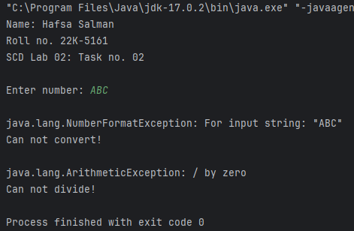

**Task no. 03**

Code:

//Hafsa Salman  
//Roll no. 22K-5161  
//Task no. 03  
  
import java.util.Scanner;  
  
public class Task_03  
{  
 public static void main(String[] args)  
 {  
  
 System.*out*.println("Name: Hafsa Salman");  
 System.*out*.println("Roll no. 22K-5161");  
 System.*out*.println("SCD Lab 02: Task no. 03");  
 System.*out*.println();  
  
 Scanner s = new Scanner(System.*in*);  
  
 int num_1, num_2;  
 int num;  
  
 System.*out*.print("Enter first number: ");  
 num_1 = s.nextInt();  
  
 System.*out*.print("Enter second number: ");  
 num_2 = s.nextInt();  
  
 try  
 {  
 num = num_1/num_2;  
 System.*out*.println("Answer after division: " + num);  
 }  
  
 catch (ArithmeticException e)  
 {  
 System.*out*.println();  
 System.*out*.println(e);  
 System.*out*.println("Can not divide!");  
 }  
  
 int array[] = new int[5];  
  
 try  
 {  
 array[0] = 0;  
 array[1] = 0;  
 array[2] = 0;  
 array[3] = 0;  
 array[4] = 0;  
 array[5] = 0;  
 }  
  
 catch (ArrayIndexOutOfBoundsException e)  
 {  
 System.*out*.println();  
 System.*out*.println(e);  
 System.*out*.println("Array is of less index.");  
 }  
 }  
}

Output:

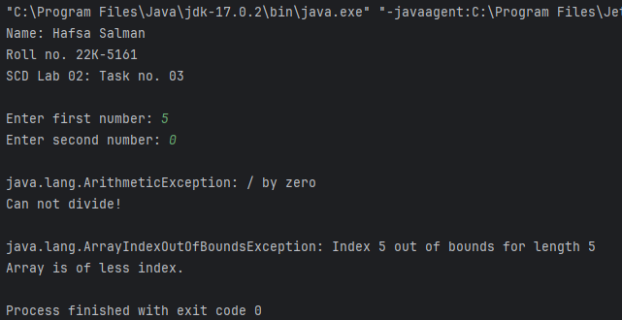

**Task no. 04**

Code:

//Hafsa Salman  
//22K-5161  
//Task no. 04  
  
import java.util.Scanner;  
  
public class Task_04  
{  
 public static void main(String[] args)  
 {  
 System.*out*.println("Name: Hafsa Salman");  
 System.*out*.println("Roll no. 22K-5161");  
 System.*out*.println("SCD Lab 02: Task no. 04");  
 System.*out*.println();  
  
 Scanner s = new Scanner(System.*in*);  
  
 Balance b = new Balance(1000);  
  
 int amount;  
  
 System.*out*.println("//Balance: 1000");  
 System.*out*.println();  
  
 System.*out*.print("Enter amount you want to withdraw: ");  
 amount = s.nextInt();  
  
 try  
 {  
 b.CheckBalance(amount);  
 }  
  
 catch (InsufficientBalanceException e)  
 {  
 System.*out*.println(e.getMessage());  
 }  
 }  
}  
  
class Balance  
{  
 int balance;  
  
 public Balance (int balance)  
 {  
 this.balance = balance;  
 }  
  
 public void CheckBalance(int amount) throws InsufficientBalanceException  
 {  
 if (balance - amount < 100)  
 {  
 throw new InsufficientBalanceException("\nEXCEPTION: The balance should not go below $100!");  
 }  
  
 else  
 {  
 balance = balance - amount;  
  
 System.*out*.println("Withdrawal Successful!");  
 System.*out*.println("Current Balance: " + balance);  
 }  
 }  
}  
  
class InsufficientBalanceException extends Exception  
{  
 public InsufficientBalanceException(String Message)  
 {  
 super(Message);  
 }  
}

Output:

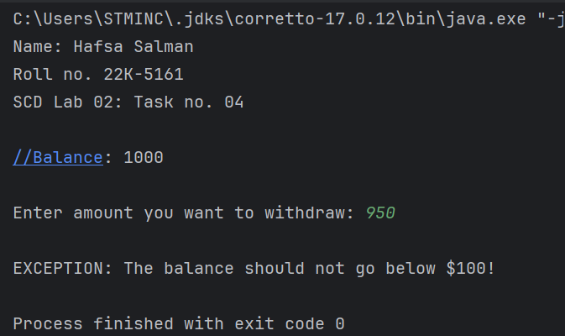

**Task no. 05**

Code:

//Hafsa Salman  
//22K-5161  
//Task no. 05  
  
import java.io.File;  
import java.io.FileNotFoundException;  
import java.io.FileReader;  
import java.io.IOException;  
  
public class Task_05  
{  
 public static void main(String[] args)  
 {  
 System.*out*.println("Name: Hafsa Salman");  
 System.*out*.println("Roll no. 22K-5161");  
 System.*out*.println("SCD Lab 02: Task no. 05");  
 System.*out*.println();  
  
 FileReader fr = null;  
  
 try  
 {  
 File f = new File("ABC.txt");  
  
 fr = new FileReader(f);  
  
 int data;  
  
 while ((data = fr.read()) != -1)  
 {  
 System.*out*.print((char) data);  
 }  
 }  
  
 catch (FileNotFoundException e)  
 {  
 System.*out*.println("File not found " + e.getMessage());  
 }  
  
 catch (IOException e)  
 {  
 System.*out*.println("Error reading file " + e.getMessage());  
 }  
  
 finally  
 {  
 if (fr != null)  
 {  
 try  
 {  
 fr.close();  
 System.*out*.println("File closed successfully!");  
 }  
  
 catch (IOException e)  
 {  
 System.*out*.println("Error closing file " + e.getMessage());  
 }  
 }  
 }  
 }  
}

Output:

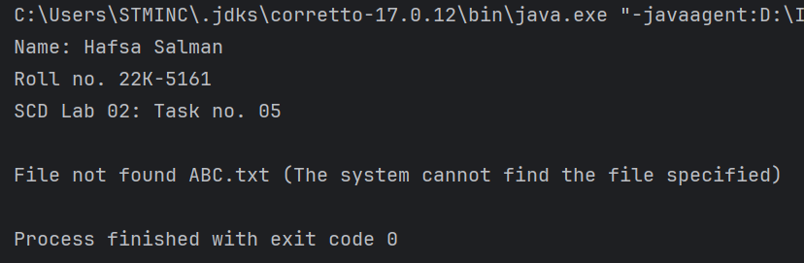

**Task no. 06**

Code:

//Hafsa Salman  
//22K-5161  
//Task no. 06  
  
import java.io.IOException;  
  
public class Task_06  
{  
 public static void Exceptionnn() throws IOException  
{  
 throw new IOException("IO Exception!");  
}  
  
 public static void main(String[] args)  
 {  
 System.*out*.println("Name: Hafsa Salman");  
 System.*out*.println("Roll no. 22K-5161");  
 System.*out*.println("SCD Lab 02: Task 06");  
 System.*out*.println();  
  
 try  
 {  
 *Exceptionnn*();  
 }  
  
 catch (IOException e)  
 {  
 System.*out*.println(e.getMessage());  
 }  
 }  
}

Output:

